

BLOCKCHAIN–BASED DONATION AND RELIEF
TRANSPARENCY SYSTEM

A Capstone Project
Presented to the Faculty of the
College of Computer Studies
Saint Joseph College
Maasin City, Southern Leyte

In Partial Fulfillment
of the Requirements for the Degree of
BACHELOR OF SCIENCE IN INFORMATION TECHNOLOGY

Leslie Faye Baltazar
Reva Grace Faith A. Saga
Edrian Jade Ambalong
Gester C. Macaldo
Niño Carl Vincent Cas
Meldwin A. Bato
Rainelyn C. Villaranda

JUNE 2026
INTRODUCTION

Financial transparency and data integrity are fundamental pillars for any organization handling monetary transactions. In the context of information technology, securely tracking financial inflows and outflows ensures operational accountability and builds trust between an enterprise and its stakeholders. Utilizing robust software algorithms to manage these records is essential to prevent discrepancies, maintain accurate financial ledgers, and streamline operations. A reliable digital infrastructure guarantees that critical data remains consistent and strictly protected against unauthorized alterations throughout the entire financial lifecycle.

The primary beneficiaries of this study encompass independent non-governmental organizations, private sector groups, and recognized student organizations, such as the College of Computer Studies, that actively supervise local relief operations and donation drives. These entities frequently initiate fundraising campaigns during times of crisis, calamity, or community outreach. They serve as the critical bridge connecting voluntary donors to direct beneficiaries, handling the collection, management, and eventual distribution of the gathered resources.

However, a critical vulnerability within current fundraising operations is the reliance on opaque fund management practices, where donors lack real-time transparency regarding the exact flow and destination of their contributions. Traditional database management systems and centralized spreadsheet ledgers used to track these funds are highly susceptible to manual tampering, unauthorized editing, or accidental data loss. Furthermore, processing these donations through standard third-party payment gateways incurs substantial transaction fees and centralized deductions, which significantly reduces the actual financial aid that reaches the intended beneficiaries.

To fundamentally resolve these IT vulnerabilities, there is a strong need to engineer a better approach to improve the present condition of fund management. This study proposes the development of the "Blockchain-Based Donation and Relief Transparency System." By developing this proposed software, the objective is to eliminate the data integrity flaws of traditional recording methods and provide these organizations with a modernized, secure, and fully accountable digital platform for managing relief operations.

OBJECTIVES OF THE STUDY

General Objective
The main objective of the project is to design and develop a transparent, web-based donation tracking system that eliminates third-party processing fees by leveraging blockchain technology.
Specific Objectives
Specifically, it aims to:
- Design and develop a web-based decentralized application called the Blockchain-Based Donation and Relief Transparency System (BBDRTS) which will be capable of:
- providing a user-friendly web interface with defined user roles, access controls, and transparent accountability metrics for donors and administrators;
- executing automated smart contracts to streamline transactions, ensure proper fund distribution, and eliminate reliance on financial intermediaries;
- utilizing an immutable public blockchain infrastructure to enable end-to-end donation tracking and ensure the data integrity and auditability of all transactions;
- integrating Web3 technologies to establish secure, wallet-to-wallet communication between the user interface and the decentralized network.
- Evaluate the performance and software quality of the BBDRTS to determine its compliance with ISO 9126 evaluation standards; and
- Prepare a comprehensive implementation and deployment plan for the successful roll-out and operation of the BBDRTS.
PURPOSE AND DESCRIPTION

System Description
The proposed software is a decentralized, web-based donation tracking platform engineered to provide a secure and transparent ecosystem for managing relief operations.
After providing its primary function, the Blockchain-Based Donation and Relief Transparency System (BBDRTS) have the following capabilities:
- Enables direct wallet-to-wallet transactions, allowing donors to send financial assistance directly to managing organizations without the need for traditional third-party payment gateways.
- Maintains an immutable public ledger through blockchain technology, guaranteeing that all transaction records are tamper-proof and cannot be unauthorizedly edited or deleted.
- Automates the execution of financial workflows using smart contracts to ensure proper and timely fund distribution based on predefined rules.
- Provides an end-to-end real-time tracking interface, giving users full visibility on the exact flow and destination of their contributions.

Project Purpose
The primary purpose of developing this system is to resolve the critical vulnerabilities of traditional donation management—specifically the lack of real-time transparency and the heavy reliance on costly third-party intermediaries. The project focuses on its contribution to its specific beneficiaries rather than adding to the general body of knowledge. Once implemented, it will provide significant benefits particularly to the following:

Independent NGOs and Student-led Organizations: These entities will benefit by having a secure, modernized platform for their fundraising campaigns. The system reduces their administrative overhead in manually tracking funds and protects them from data loss, ultimately increasing their credibility and trust among donors.

The Donors / General Public: The system provides donors with absolute transparency and peace of mind. By allowing them to publicly verify the exact flow of their contributions, it eliminates opaque fund-tracking practices and restores donor confidence in local relief operations.

The Ultimate Beneficiaries: The individuals or communities affected by crises will directly benefit from the system's elimination of corporate payment gateway fees. Because third-party processing deductions are removed, a maximized and larger portion of the donated funds directly reaches them.

The Researchers: By developing this complex Web3 architecture, the researchers will greatly improve their technical proficiencies in smart contract deployment, decentralized application (dApp) integration, and IT project management, preparing them for advanced roles in the modern software industry.

SCOPE AND LIMITATION OF THE STUDY

The primary objective of this study is to develop a Blockchain-Based Donation and Relief Transparency System that addresses the issues of mistrust and lack of accountability in traditional donation processes. By utilizing a decentralized ledger, the system aims to provide a tamper-proof and verifiable record of all transactions, ensuring that every monetary contribution reaches its intended recipient without unauthorized intervention. The target users and beneficiaries of this system include donors seeking a transparent way to track their contributions, non-governmental organizations (NGOs) needing an efficient and credible platform to manage relief operations, and student groups facilitating small-scale donation drives for community service or emergency response.

The study and development of the software will be conducted over a period of two (2) months, specifically from May 2026 to June 2026. This timeframe includes the system design, smart contract coding, testing, and final evaluation of the software’s performance. To achieve this, the proposed software features an immutable transaction ledger to ensure data cannot be deleted or altered once stored, and smart contract automation that automatically executes and validates the release of funds once predefined conditions are met. It also provides a real-time tracking dashboard for donors, a secure portal for registered organizations to create relief campaigns, and a digital receipting system that generates unique transaction hashes to serve as digital proof of donation for all parties involved.

However, the study is delimited to the following parameters: the system is strictly limited only to monetary donations and does not cover the tracking or management of in-kind donations. Transactions are restricted exclusively to blockchain-based transfers using Web3-enabled wallets to maintain full transparency and prevent the oracle problem. Operational processes, such as physical beneficiary registration or manual goods distribution, are not handled by the system and remain the sole responsibility of the partner relief organizations.

LIMITATION OF THE STUDY

Internet Dependency
The system requires a stable internet connection because all blockchain transactions are processed online. Poor or unstable connectivity may delay transaction submission and confirmation since the blockchain network needs continuous communication between nodes.

Use of Sepolia Testnet
The system uses the Sepolia Testnet instead of a live blockchain mainnet. Since testnets are intended only for development and testing purposes, the system does not process transactions with actual financial value. Additionally, network performance, transaction speed, and gas fee behavior in real-world production environments may differ from the conditions experienced within the testnet environment.

Network Congestion and Scalability
Blockchain networks may become slow when many users are processing transactions at the same time. Because transactions are validated in blocks, heavy network traffic can cause delays in transaction confirmation.

Gas Fee Fluctuation
Although the system reduces third-party payment fees, blockchain transactions still require gas fees for processing. These fees depend on network demand and may increase or decrease unexpectedly.
Dependence on Third-Party Blockchain Services
The system relies on external blockchain services such as the Ethereum network and wallet providers like MetaMask. Any downtime, maintenance, or technical issues from these services may affect the system’s performance and availability.

Irreversible Transactions
Blockchain transactions cannot be changed or canceled once confirmed. This is a built-in security feature of blockchain technology, but incorrect transactions cannot be automatically reversed by the system.

THEORETICAL FRAMEWORK

The framework of this study is anchored on three established theories and models that support the implementation of a decentralized and transparent system for relief operations.

Transparency Theory
Transparency Theory (Schnackenberg & Tomlinson, 2016) states that organizations gain trust and credibility when their operations and financial activities are openly accessible and verifiable by stakeholders. In the context of the Blockchain-Based Donation and Relief Transparency System (BBDRTS), this theory is directly relevant because the platform utilizes blockchain technology to provide transparent and immutable donation records. By allowing donors and organizations to track transactions in real time, the system effectively promotes accountability, minimizes the risk of fund mismanagement, and restores donor trust through verifiable data presentation.

Distributed Trust Model
The Distributed Trust Model (Botsman, 2017) shifts the concept of trust from traditional, centralized institutions to a decentralized network of peers, where transparency and security are maintained through collective verification rather than a single authority. This model is highly relevant to the BBDRTS as it eliminates the reliance on a traditional middleman or third-party payment gateway to validate operations. Instead of trusting a single central entity, the platform leverages peer-to-peer validation and automated smart contracts, ensuring that all donation data and fund routing are verified and permanently recorded by the network consensus.

Smart Contract Theory
Smart Contract Theory (Szabo, 1997) posits that transactional protocols can be fully automated and embedded within a digital environment to enforce the terms of an agreement without a trusted third party. This theory serves as the technical backbone of the BBDRTS. By utilizing self-executing smart contracts on the blockchain, the system removes the need for human intervention in fund routing, thereby eliminating administrative delays, reducing intermediary fees, and removing the potential for data tampering during the transfer process.

Principal-Agent Theory
The Principal-Agent Theory (Jensen & Meckling, 1976) explains the conflicts of interest and trust issues that arise when one party delegates decision-making authority to another. In traditional donation setups, this highlights the inherent risk of fund mismanagement when agents have full control over the money with little oversight. The BBDRTS addresses this agency problem by enforcing strict cryptographic rules and utilizing public ledgers, ensuring the organization's actions and the exact flow of funds remain entirely visible and accountable to the donors.

Information Asymmetry Theory
Information Asymmetry Theory (Akerlof, 1970) occurs when one party in a transaction possesses more or better information than the other. In charitable giving, organizations typically know exactly how funds are spent, while donors remain largely uninformed, leading to hesitation. The BBDRTS combats information asymmetry by providing a real-time transparency dashboard. By democratizing financial data on the blockchain ledger, both the donor and the organization share the exact same verifiable information regarding the campaign's progress and expenditures.

Stakeholder Theory
Stakeholder Theory (Freeman, 1984) asserts that an organization must create value for all its stakeholders, rather than focusing solely on a single governing body. Within the BBDRTS ecosystem, the stakeholders include the donors, the student organizations, the system administrators, and the ultimate beneficiaries. The decentralized nature of the system ensures that the interests of all these groups are securely protected: donors receive absolute transparency, organizations gain a highly credible fundraising platform, and beneficiaries receive funds free from third-party payment gateway deductions.

Decentralized Network Theory
Decentralized Network Theory (Baran, 1964) emphasizes the resilience and security of a system that lacks a single central point of failure. Traditional financial databases are centralized and inherently vulnerable to single-point hacking, server downtimes, or internal data manipulation. The BBDRTS applies this theory by deploying its ledger across the distributed Web3 network. Because the transaction data is distributed across and verified by multiple independent nodes, the system achieves immutable security, making it structurally impossible for any single entity to alter the donation records.

CONCEPTUAL FRAMEWORK AND DESIGN

IPO Model and Process Diagrams

The conceptual framework of the Blockchain-Based Donation and Relief Transparency System (BBDRTS) is structured using the Input-Process-Output (IPO) Model to illustrate the logical flow of the system's core operational functionality. This framework provides a systematic mapping of how user requirements and cryptographic configurations are processed by the decentralized architecture to produce a transparent and tamper-proof auditing environment for relief operations.

The Input phase encompasses the essential data and cryptographic configurations required to initialize the system's ecosystem. This includes donor, NGO, and student organization user data, which links their system profiles directly to their unique Web3 wallet addresses. It also captures cryptocurrency donation information, specifically restricted to monetary digital assets to prevent the oracle problem, alongside authorized campaign details created by verified organizations. Finally, this phase integrates smart contract parameters and blockchain network configurations, such as the Sepolia Testnet endpoints and MetaMask wallet integration settings.

The Process phase represents the automated, real-time backend and blockchain-level operations that transform the initialized inputs into functional, secure data states. This covers automated smart contract fund execution, which programmatically routes crypto assets directly from donors to targeted organization addresses without manual third-party intervention. It also includes cryptocurrency transaction validation and cryptographic signature verification executed via the decentralized Sepolia Testnet network nodes. Once validated, the system performs permanent, immutable updating of the public blockchain ledger and handles real-time data retrieval to dynamically update the web application's user interface.

The Output phase details the tangible, verifiable deliverables generated by the platform as a result of these automated network functions. The primary output is verified testnet transactions that simulate secure, zero-cost asset transfers, establishing a permanent and tamper-proof audit trail on the public blockchain ledger. This data populates the live transparency dashboard interface, allowing donors and administrators to monitor contributions from the exact second of initiation down to the final distribution. Lastly, the system outputs digital transaction receipts containing unique transaction hashes (TxHashes) and triggers trustless automated fund routing directly to the partner organization's Web3 wallet. Together, these interconnected phases demonstrate how decentralized ledger technology is applied to enforce financial accountability and eliminate the vulnerabilities of fraud and mistrust that historically compromise traditional relief operations.
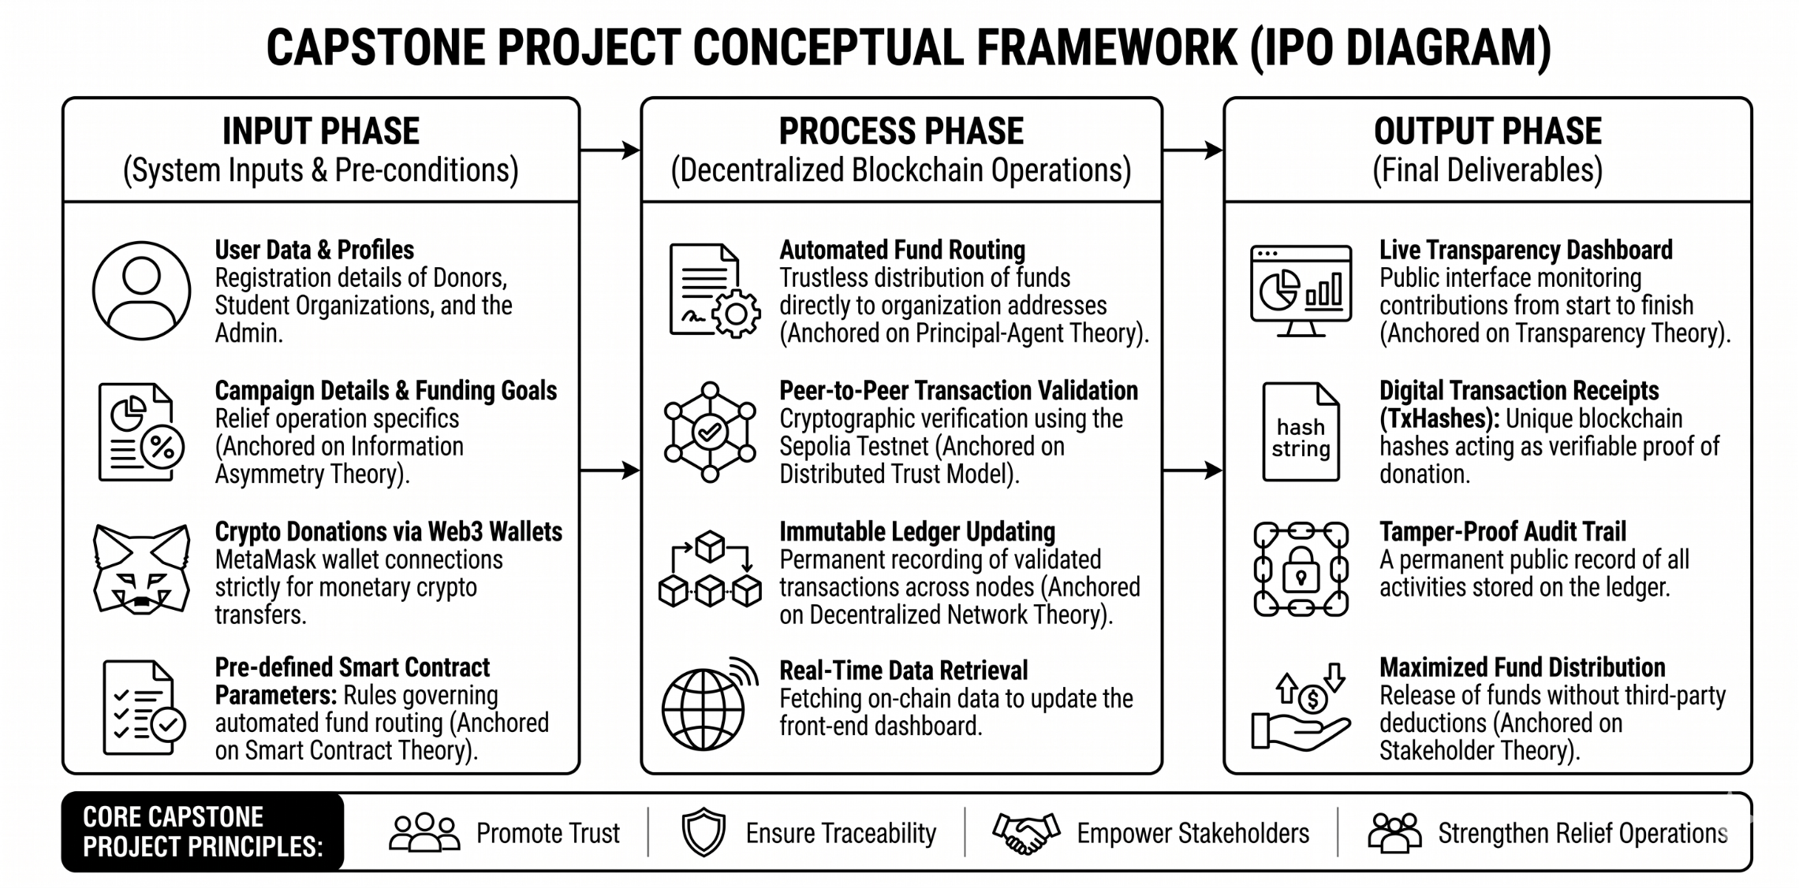
Design of Software, Systems, Product and/or Process

To further elaborate on the actual behavioral flows, structural boundaries, and data management mechanisms of the BBDRTS, the architectural design is modeled using Data Flow Diagrams (DFDs) and an Entity-Relationship Diagram (ERD). These structural models visually depict the interfaces, logical sub-processes, and strict relational constraints governing the platform.

1. Context Diagram (Level 0 DFD)

The Context Diagram establishes the baseline boundary of the BBDRTS by representing the entire platform as a single system process interface (Process 0) interacting directly with the external entities: the Administrator, the Donor, and the Recipient Organization. It defines the high-level inputs and outputs without diving into sub-system complexities.

2. Level 0 Data Flow Diagram

The Level 0 Data Flow Diagram expands the central system process into detailed functional sub-processes: Manage Accounts & Platform (1.0), Manage Relief Campaigns (2.0), Process Donations via Smart Contract (3.0), and Generate Transparency Reports (4.0). It illustrates how data transitions dynamically through these sub-processes and maps out the distinct boundaries between the off-chain application database and the immutable on-chain ledger.

3. Entity-Relationship Diagram (ERD)

The Entity-Relationship Diagram maps the logical and physical layout of the database schema supporting the BBDRTS. To maintain absolute operational normalization and strictly adhere to relational integrity, all many-to-many relationships are resolved using the Donation Transaction entity as a junction table. The schema ensures structured entity mappings across the Administrator, Organization, Campaign, Donor, and Transaction tables using explicit Primary Key (PK) and Foreign Key (FK) relational paths.

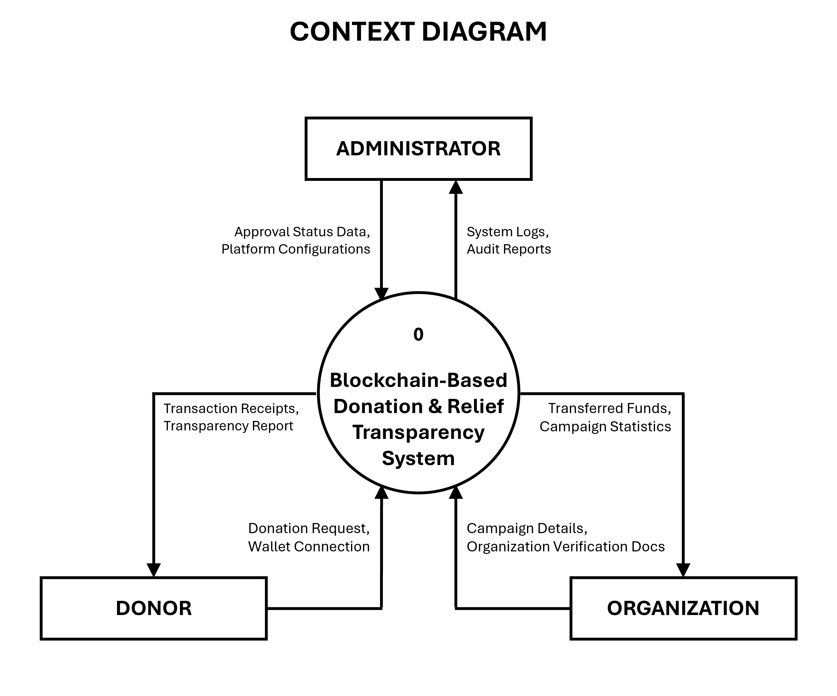

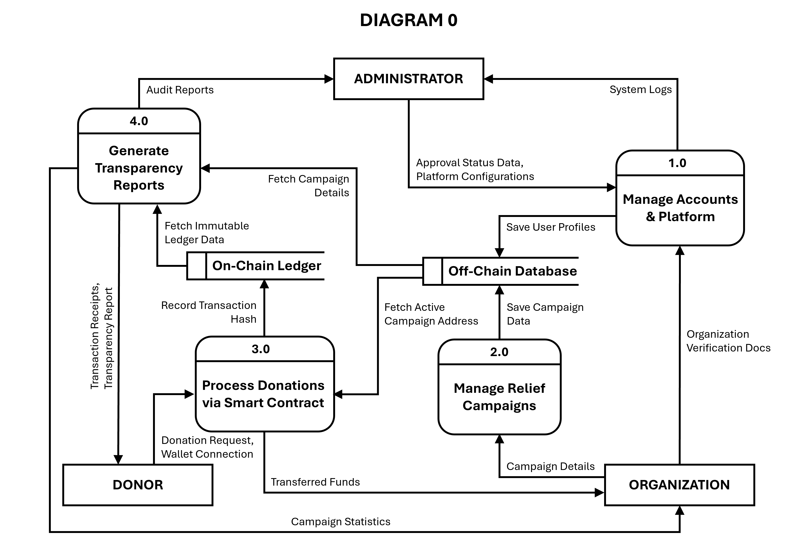
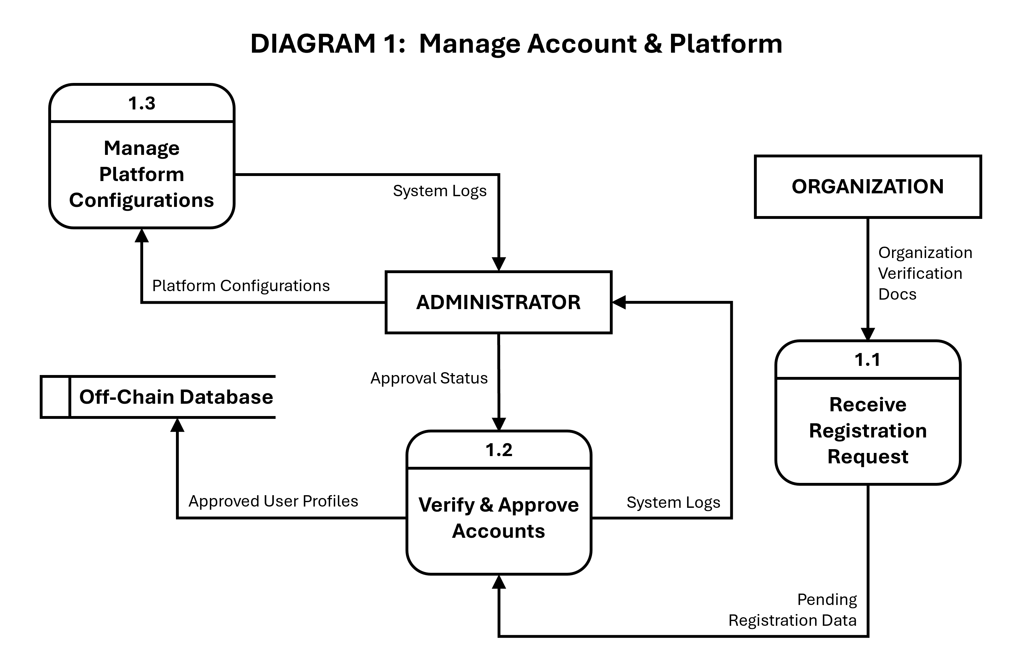
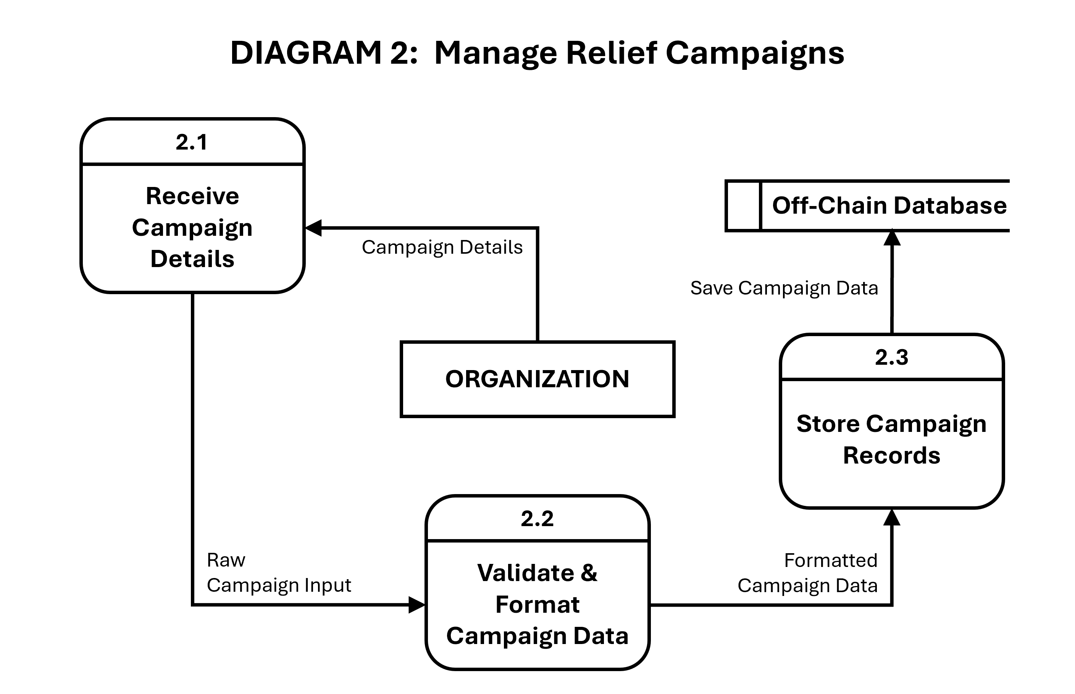
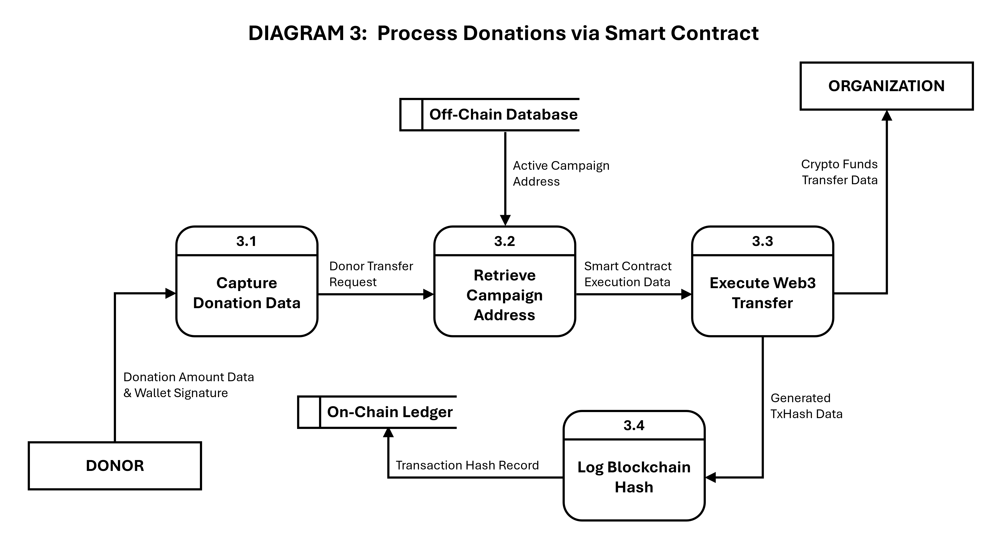
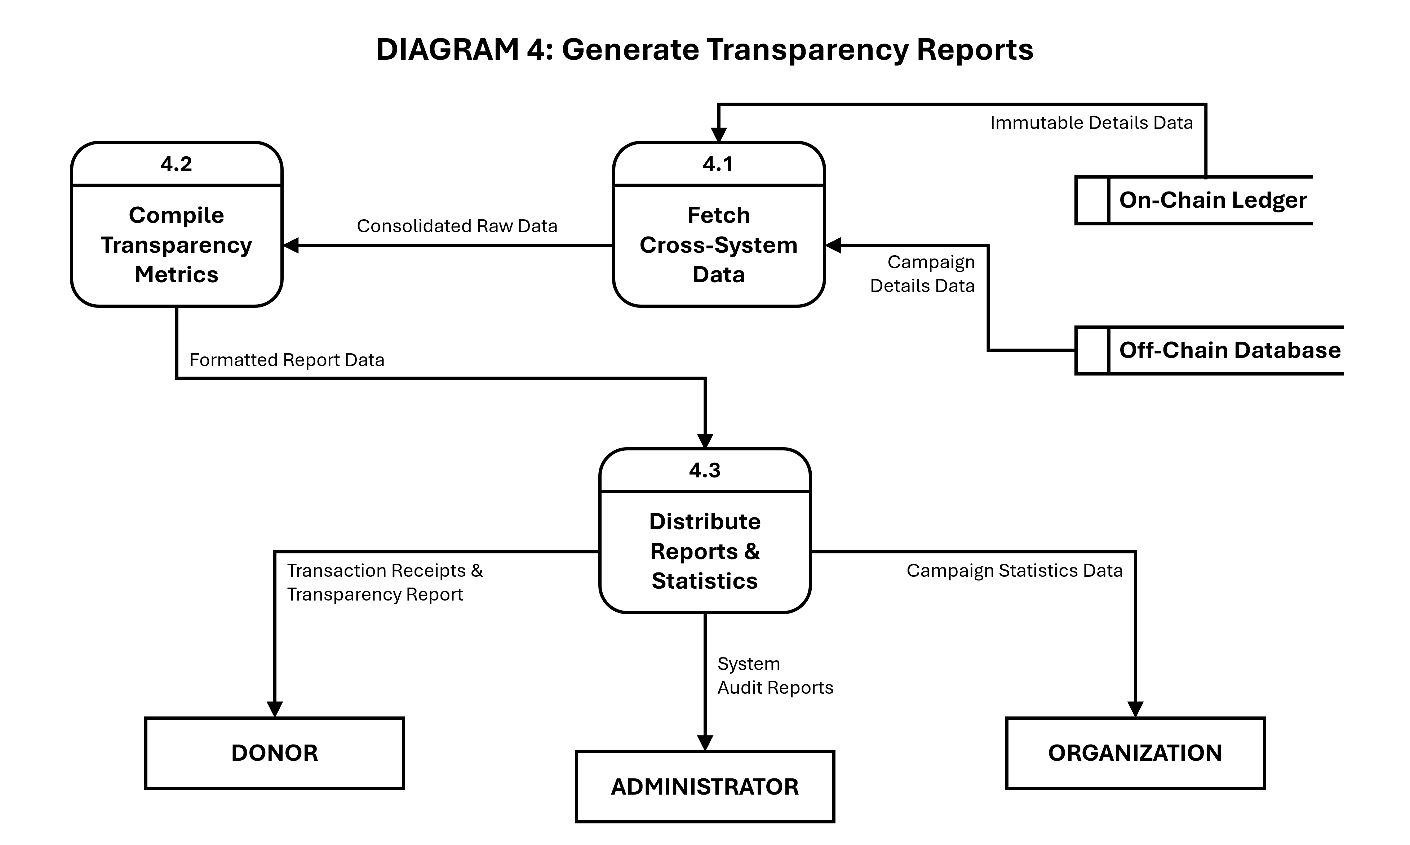
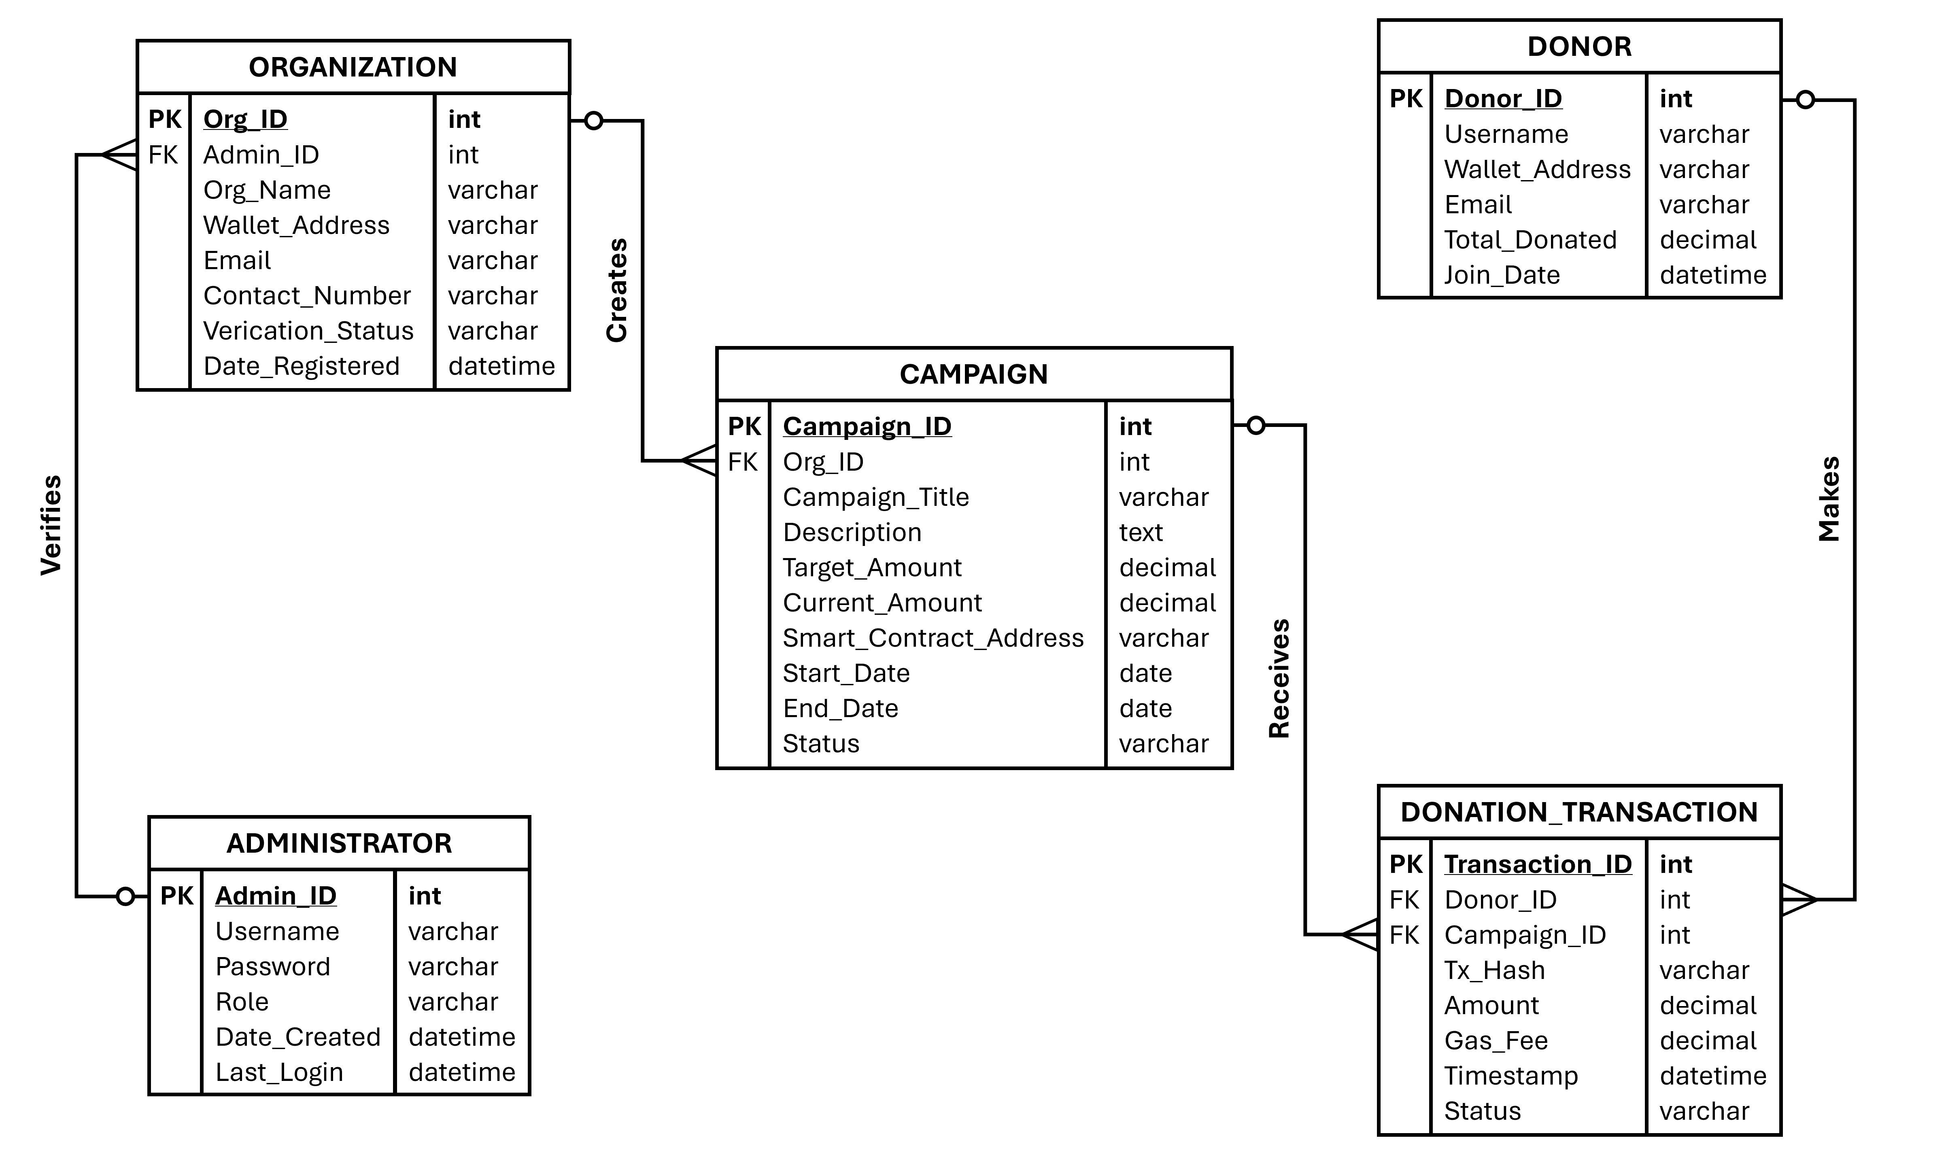
METHODOLOGY AND SOFTWARE EVALUATION

Design and Methodology

This study will utilize the Agile Software Development Methodology in developing the Blockchain-Based Donation and Relief Transparency System (BBDRTS). Agile methodology is highly suitable for this study because it allows for an iterative approach where the system is developed step by step through continuous cycles of planning, designing, coding, testing, and structural improvement. Since the platform involves distinctly different users, specifically donors, non-governmental organizations (NGOs), and administrators, the Agile framework helps the development team make swift operational adjustments based on user requirements and collaborative feedback gathered during the development lifecycle. The systematic development of the BBDRTS follows six core operational phases.

During the Requirement Analysis phase, the core needs and structural requirements of the platform are comprehensively identified. The primary user pathways are established: donors must be able to securely connect Web3 wallets, execute monetary donations, and view historical transaction receipts; partner organizations require interfaces to deploy relief campaigns, monitor incoming ledger transfers, and post operational updates; and administrators must access dashboards to manage platform users, verify NGO registration documents, monitor network activities, and audit system performance logs. This phase also analyzes the persistent vulnerabilities within traditional donation management environments, such as a severe lack of real-time transparency, the high potential for database tampering, and heavy reliance on centralized third-party payment gateways. These identified criteria serve as the explicit foundation for the system design and coding iterations.

In the System Design phase, the blueprint of the software architecture is formulated through Context Diagrams and Data Flow Diagrams (DFDs). These behavioral models visually map out how sensitive information flows securely between the system and its external entities. Structurally, this phase establishes a clear architectural division: an off-chain application database is utilized to securely manage standard user credentials, relief campaign descriptions, and administrative verification documentation, while decentralized blockchain ledger infrastructure is reserved strictly to record active smart contracts, automated cryptocurrency transactions, and permanent transaction hashes. This multi-tier architecture optimizes data security while enforcing absolute system transparency.

During the System Development phase, the actual web-based prototype is programmatically constructed based on the approved specifications. Development activities are focused on frontend user interfaces, secure registration frameworks, campaign creation blocks, and interactive transparency dashboards. Crucially, Web3 technology modules are integrated to bridge the user interface with the blockchain network, deploying specialized smart contracts written in Solidity to fully automate and cryptographic validation of donation handshakes directly between peers without human or institutional intermediaries.

In the Testing and Debugging phase, the software undergoes exhaustive testing iterations to confirm that all technical elements execute without failure . The test scripts focus heavily on MetaMask wallet configurations, successful smart contract deployment, cryptographic transaction validation, accurate TxHash retrieval, and automated dashboard updating. To protect developer resources and prevent real financial loss during structural iterations, testing is executed entirely within the isolated environment of the Ethereum Sepolia Testnet. Any runtime errors, logic flaws within the smart contracts, or front-end integration bugs caught during this period are systematically debugged and corrected before advancing to stakeholder verification.

During the System Evaluation phase, the finalized prototype is rigorously evaluated using standardized software quality instruments, specifically tracking criteria like functionality, reliability, usability, efficiency, maintainability, and portability. This formal process provides quantifiable metric verification regarding whether the decentralized platform functions as a secure, efficient, and user-friendly alternative to legacy systems. Evaluator insights, feedback data, and user surveys are analyzed to fine-tune system latency and ensure the application perfectly fits the core objectives of the study.

Finally, in the Implementation and Documentation phase, the final production build of the software is secured alongside its extensive project documentation. This encompasses the compilation of verified DFD models, database schema configurations, smart contract transaction receipts, user evaluation spreadsheets, and system operator instructions. This phase guarantees that the completed BBDRTS framework is soundly documented, reproducible, and ready for public demonstration and final thesis defense.

